8 Way Vertically Mounted Rackmount 32A Commando PDU - UK Sockets (PDU-8WS-V-32CMDO)

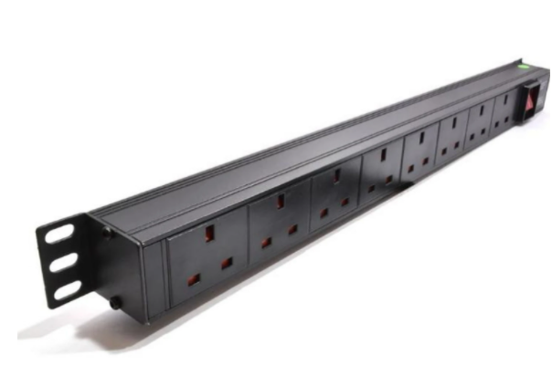

Description:
The LMS Power PDU-8WS-V-32CMDO is a high-quality vertically mounted PDU (Power Distribution Unit) that simply fits within the universal mounting brackets of data, telecom and server cabinets.
A must-have accessory for your data cabinets if you need to provide effective power to devices including Ethernet Switches, Servers, UPS, NAS and of course cabinet accessories including cooling fan trays.
Robust, alloy design complete with rackmount brackets fitted, high-quality Neon Switch and of course UK output sockets together with a high quality, 32-Amp rated extra heavy duty Commando power input plug, ideal for industrial usage.

Key Features:
Standard UK 3-Pin power outlets for your appliances
Extra HD 32 Amp Commando Plug for industrial applications
1U high means the PDU can fit into the smallest cabinet
Neon On/Off Rocker switch to prevent accidental turn off
Backed up by LMS Power's exclusive 3-year warranty

Product Code:
Part Number: PDU-8WS-V-32CMDO
EAN: 84008000361627
Weight: 1.6Kg approx

Technical Specifications:
Warranty LMS Data 3-Year Warranty
Chassis 1U vertical mount with mounting brackets
Output Sockets 8 UK 3-PIN Sockets
Power Input Fitted 32-Amp HD Commando Plug
Flex Length 1.8 metres (approx)
Power Control On/Off Rocker Switch (illuminated)
Power Rating 4000 Watts (approx)

Supplied With:
PDU-8WS-V-32CMDO 8 Way Vertical PDU
19-inch cabinet brackets (Fitted)
* Specifications and product design are subject to change. E&OE.

Looking for high-performance power distribution for your heavily loaded systems using the industry standard 32 amp commando plug power input? The newly developed LMS Data 32A heavy-duty vertical PDU is ideal for high-loading device requirements including server, network and other industrial-type equipment functions such as broadcast and HVAC applications. Combining a fully certified commando type 32A plug input, combined with a compatible heavy load power flex means you can be assured this LMS Data PDU can work without problems, 24/7. Ideal for vertical placement in wide range of data, server and broadcast cabinets that need a higher load equipment environments. Robust in design, with an integral illuminated power input status, the LMS Data PDU is designed to deliver maximum electrical power today and tomorrow.

specifications:
Vertical, high-performance Power Distribution Unit (PDU)
Heavy-load 32A Commando style 3-pin plug
Compatible, heavy-load power cable
x8 UK style output power sockets - Non surge protection
Robust, black aluminium design for industrial use
Illuminated power input light for assured power status
Maximum power rating - 4000W nominal
1.8 metre (approx.) power cordage - 3x4mm2 dimensions
Ideal for data, telecom, broadcast and HVAC applications

